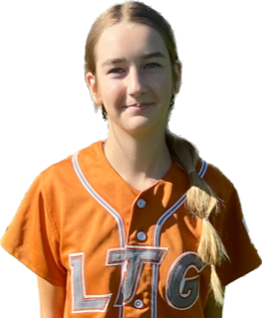 | Abigail Sova #28
 | Position:  Birth Mo/Year:  High School: |  |  | OF  March 2009  Will C Wood HS, Vacaville, CA
 | ATHLETIC INFORMATION
 | Bats: Left |  | Throws: Right |  | Home to 1B: #.##
 | ACADEMIC INFORMATION |  |  |  |  | NCAA Clearinghouse #: ##########
 | GPA Weighted: 4.0 / Unweighted 4.0 |  |  |  |  |  | SAT: #### |  | ACT: ##
2027 | LTG Lions 14U Henderson/Buck
CONTACT INFORMATION  P. 707-803-6248  E. abigailsova2027@gmail.com  HEAD COACH / LIAISON  Joe Henderson  P. (916) 947-7331  E. joehenderson@frontiernet.net  Amanda Buck  P. (916) 479-5048  E. ltgbuck@gmail.com  SPECIALTY COACHES  Hitting:  Joe Marks  C: (707) 246-7581  Speed & Agility: |  | Athletic Accomplishments  - 2023 PGF Nationals 14u Premier T-17th Place Finish  - 2023 PGF Organizational Challenge Winners  - 2022 PGF Nationals 12u Premier T-7th Place Finish  ACADEMIC ACCOMPLISHMENTS  - 2022-23 Principal’s Honor Award  Community Service  - 2023- Present: Service Learning High School Leadership  travel ball history  - 2023-present: LTG Lions 14U Henderson/Buck  - 2022-2023: LTG Lions 14U Henderson/Buck  - 2021-2022: LTG Lions 12U Henderson/Buck  - 2020-2021: LTG Lions 12U Henderson/Buck  - 2019-2020: PS33 Academy, Sacramento CA

