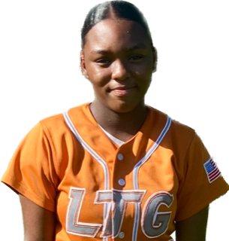 | Amyia Clay #13
 | Position:  Birth Mo/Year:  Middle School: |  |  | OF / 1B  August 2009  Golden West Middle School, Fairfield, CA
 | ATHLETIC INFORMATION
 | Bats: Left |  | Throws: Right |  | Home to 1B: #.##
 | ACADEMIC INFORMATION |  |  |  |  | NCAA Clearinghouse #: ##########
 | GPA Weighted: 3.8 / Unweighted: 3.8 |  |  |  |  |  | SAT: #### |  | ACT: ##
2028 | LTG Lions 14U Henderson/Buck
CONTACT INFORMATION  P. (707) 688-8458  E. Amyiaclay2028@outlook.com  HEAD COACH / LIAISON  Joe Henderson  P. (916) 947-7331  E. joehenderson@frontiernet.net  Amanda Buck  P. (916) 479-5048  E. ltgbuck@gmail.com  SPECIALTY COACHES  Hitting:  Michael Faulstich  P. (707) 628-2020  E. mfaulstich@yahoo.com |  | Athletic Accomplishments  - 2023 Extra innings rankings #117 overall C/O 2028  - 2022 Extra innings rankings #47 OF C/O 2028  - 2023 PGF Nationals 14u Premier T-17th Place Finish  - 2023 PGF Organizational Challenge Winners  - 2022 PGF Nationals 12u Premier T-7th Place Finish  ACADEMIC ACCOMPLISHMENTS  - 2023 GPA 3.8 Principals Honor Roll  - 2022 GPA 3.5 Principals Honor Roll  Community Service  travel ball history  - 2021-Current: LTG Lions 2027 Henderson/Buck, Elk Grove  - 2020-21: Lady Magic 2009 Munoz, Elk Grove  - 2019-20: Universal Fastpitch 2027 White, Martinez  - 2018-19: SC Swat 10U, Fairfield

