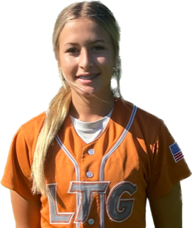 | Brooklyn Nicholls #39
 | Position:  Birth Mo/Year:  High School: |  |  | 3B / 1B  March / 2009  Central Catholic High School, Modesto, CA
 | ATHLETIC INFORMATION
 | Bats: Right |  | Throws: Right |  | Home to 1B: 2.96
 | ACADEMIC INFORMATION |  |  |  |  | NCAA Clearinghouse #: ##########
 | GPA Weighted: 3.89 / Unweighted: 3.89 |  |  |  |  |  | SAT: TBD |  | ACT: TBD
2027 | LTG Lions 14U Henderson/Buck
CONTACT INFORMATION  P. (209) 650-8155  E. brooklynnicholls2027@gmail.com  HEAD COACH / LIAISON  Joe Henderson  P. (916) 947-7331  E. joehenderson@frontiernet.net  Amand Buck  P. (916) 479-5048  E. ltgbuck@gmail.com  SPECIALTY COACHES  Hitting:  Shelby Weeks  All-American Sports Academy  C. (916) 801-8903  Katie Roher  All-American Sports Academy  C. (707) 494-5179  Speed & Agility:  Sam Nichols  Central Catholic  C. (209)543-2616 |  | Athletic Accomplishments  - 2023 Central Elite Softball Camp Modesto, CA  - 2022 Central Elite Softball Camp Modesto, CA  - 2022 PGF Nationals 12u Premier-Universal Fastpitch-3rd Place Finish  - 2022 Cal Berkley Softball Camp  ACADEMIC ACCOMPLISHMENTS  - 2023 Central Catholic High School Honor Roll Fall Trimester  - 2020-23 St. Bernard’s Middle School Principals Honor Roll  Community Service  - 2019-Present: Saint Bernard’s Catholic Church Youth Group, Member/Volunteer  - 2022 Toys for Tots, Volunteer  - 2021-22 Brighter Christmas Drive The Bay Church, Volunteer  travel ball history  - 2023-Current: LTG Lions 14U Buck, Elk Grove  - 2019-2023 Universal Fastpitch 2027 White/Savoy, Martínez
2

