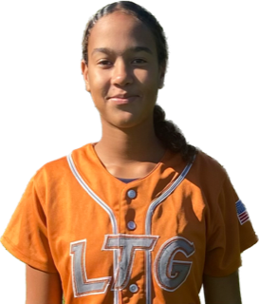 | Cat Alston #2
 | Position:  Birth Mo/Year:  High School: |  |  | OUTFIELD  January 2009  Rocklin High School
 | ATHLETIC INFORMATION
 | Bats: Left |  | Throws: Right |  | Home to 1B: 2.78
 | ACADEMIC INFORMATION |  |  |  |  | NCAA Clearinghouse #: ##########
 | GPA Weighted: 4.0 / Unweighted: 4.0 |  |  |  |  |  | SAT: #### |  | ACT: ##
2027 | LTG Lions 14U Henderson/Buck
CONTACT INFORMATION  P. (916) 412-1598  E. Catbird.alston@gmail.com  HEAD COACH / LIAISON  Joe Henderson  P. (916) 947-7331  E. joehenderson@frontiernet.net  Amanda Buck  P. (916) 479-5048  E. ltgbuck@gmail.com  SPECIALTY COACHES  Hitting:  Darin Delgado  EAC  C. (916) 717-4490  Speed & Agility:  Lisa Delgado  AR Softball  C. (916) 759-8517  Pitching:  Michelle Grainger  c. (916) 296-1655 |  | Athletic Accomplishments  - PGF Nationals 2019,2021,2022,2023  - PGF Nationals premier birth winner 2021  - TC Colorado sparkler 2021,2023  - USA Softball All American games OKC 2022  ACADEMIC ACCOMPLISHMENTS  - 2022-23 - GPA 4.0  Community Service  travel ball history  - 2023-Current: LTG Lions 14U Buck, Elk Grove  - 2022-2023: Hype 14U  - 2020-2022: Hype 12U  - 2019-2020: Rocklin Rebels 10U  - 2018: Rocklin Thundercats 10U

