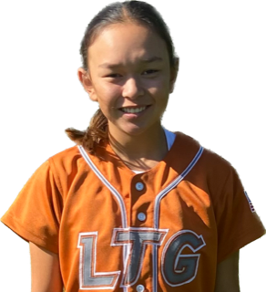 | Desiree Shoblo #4
 | Position:  Birth Mo/Year:  High School: |  |  | 2B / SS  February 2009  Alameda High School, Alameda, CA
 | ATHLETIC INFORMATION
 | Bats: Right |  | Throws: Right |  | Home to 1B: 2.9
 | ACADEMIC INFORMATION
 | GPA: 4.0
2027 | LTG Lions 14U Henderson/Buck
CONTACT INFORMATION  P. (510) 301-8156  E. desireeshoblo@gmail.com  IG : desishoblo2027  X : desishoblo2027  HEAD COACH / LIAISON  Joe Henderson  P. (916) 947-7331  E. joehenderson@frontiernet.net  Amanda Buck  P (916) 479-5048  E ltgbuck@gmail.com  SPECIALTY COACHES  Hitting:  Hailey Breakwell  Hailey Breakwell Performance LLC  C. (707) 363-0234  Speed & Agility:  Kenyatta Madison  XCL Training  C. (806) 707-3687 |  | Athletic Accomplishments  - 2023 MLB Pitch, Hit, Run Champion – Oakland A’s  - 2023 USA Softball High Performance Program (HPP) National Selection  - 2022 USA Softball High Performance Program (HPP) National Selection  - 2022 USA Softball Region 10 All American Games, OKC  - 2022 PGF Premier Nationals Universal 2027 – 3rd place  - 2022 Alameda Lincoln Middle School basketball champion - MVP  - 2022 Alameda Hoop Shoot basketball champion, 3x  - 2021 MLB Pitch, Hit Run Champion – Oakland A’s  - 2019 MLB Pitch, Hit Run Champion – SF Giants  ACADEMIC ACCOMPLISHMENTS  - 2022-23 Lincoln Middle School graduated with honors GPA 4.0  - 2020-23 Lincoln Middle School honor roll – all 3 years  Community Service  - 2020-Present: Eden Japanese Community Center, Member/Volunteer  - 2020-Present: Eden Athletic Club, Volunteer  - 2021 Santa’s Helpers Bay Church, Volunteer  travel ball history  - 2023-Present: LTG 14U Henderson/Buck, Elk Grove  - 2021-22 Universal 2027, Martinez  - 2019-21 Sorcerer Brannon, Livermore  - 2016-19 Alameda Blaze, Alameda

