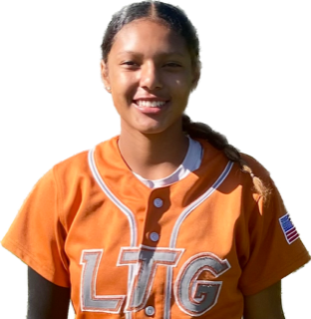 | Izianah Castillo #21
 | Position:  Birth Mo/Year:  Middle School: |  |  | SS  December 2009  Joseph Kerr Middle School
 | ATHLETIC INFORMATION
 | Bats: Right |  | Throws: Right |  | Home to 1B: 3.04
 | ACADEMIC INFORMATION |  |  |  |  | NCAA Clearinghouse #: ##########
 | GPA Weighted: 3.2 / Unweighted: 3.2 |  |  |  |  |  | SAT: #### |  | ACT: ##
2028 | LTG Lions 14U Henderson/Buck
CONTACT INFORMATION  P. (916) 769-3417  Izi.castillo2028@gmail.com  HEAD COACH / LIAISON  Amanda Buck  P. (916) 479-5048  SPECIALTY COACHES  Fielding  Ken Kenobbie  BPA Facility  C. (916) 247-2417  Hitting:  Ken Kenobbie  BPA Facility  C. (916) 247-2417  Speed & Agility:  Jakori Ford  Game-Fit  C. (916) 476-0652 |  | Athletic Accomplishments  - 2023- Region 10 USA High performance Program, Florida  - 2022-23 Extra Innings Ranking, Top-12 class of 2028  - 2022- Region 10 USA All-American Games, Oklahoma  - 2023 PGF Nationals 14u Premier T-17th Place Finish  - 2023 PGF Organizational Challenge Winners  - 2022 PGF Nationals 12u Premier T-7th Place Finish  travel ball history  - 2020-23-Current: LTG Lions 2027 Henderson/Buck, Elk Grove  - 2019-20-California Breeze 10U Daniel

