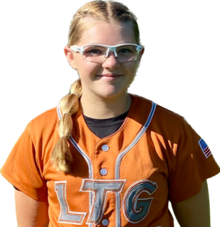 | Abigail Schweigerdt #24
 | Position:  Birth Mo/Year:  High School: |  |  | P / OF  January 2009  Lodi High School, Lodi, CA
 | ATHLETIC INFORMATION
 | Bats: Right |  | Throws: Right |  | Fastball: 61 mph |  |  | Change-Up: 48 mph |  | Home to 1B: 3.06
 | ACADEMIC INFORMATION |  |  |  |  | NCAA Clearinghouse #: N/A
 | GPA Weighted: 3.5 / Unweighted: 3.5 |  |  |  |  |  | SAT: N/A |  | ACT: N/A
2027 | LTG Lions 14U Henderson / Buck
CONTACT INFORMATION  P. (209) 331-6447  E. abbyschweigerdt@icloud.com  HEAD COACH / LIAISON  Joe Henderson  P. (916) 947-7331  E. joehenderson@frontiernet.net  Amanda Buck  P. (916) 479-5048  E. ltgbuck@gmail.com  SPECIALTY COACHES  Pitching:  Ron Engle  K-Club Academy  C. (916) 337-4624  Hitting:  Denny Gomes  D&D Softball  C. (209) 406-5138  Speed & Agility: |  | Athletic Accomplishments  - 2023 OnDeck Softball, Rosetta Canyon Jamboree – Invitee  - 2022 Triple Crown World Series, gold bracket championship game, pitcher  ACADEMIC ACCOMPLISHMENTS  - 2021-23 Millswood Middle School, Honor Roll  - 2021-23 California Junior Scholarship Federation  Community Service  travel ball history  - 2023-Current: LTG Lions 14U Henderson/Buck, Elk Grove  - 2022-23 Firecrackers 14U Tucker, Rancho Cordova  - 2021-22 Firecrackers 12U Ortiz, Rancho Cordova  - 2020-21 Elk Grove Thunder 10U Ortiz, Elk Grove  - 2019 Batbusters 10U Stallings, Lodi

