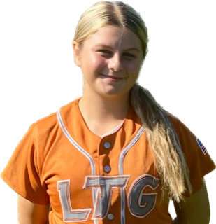 | Raelynn Hulsey #51
 | Position:  Birth Mo/Year:  High School: |  |  | 1B / 3B  May 2009  Wheatland Union High School, Wheatland, CA
 | ATHLETIC INFORMATION
 | Bats: Right |  | Throws: Right |  | Home to 1B: #.##
 | ACADEMIC INFORMATION |  |  |  |  | NCAA Clearinghouse #: ##########
 | GPA Weighted: 4.0 / Unweighted: 4.0 |  |  |  |  |  | SAT: #### |  | ACT: ##
2027 | LTG Lions 14U Henderson/Buck
CONTACT INFORMATION  P. (916) 500-1939  E. hulseyraelynn2027@icloud.com  HEAD COACH / LIAISON  Joe Henderson  P. (916) 947-7331  E. joehenderson@frontiernet.net  Amanda Buck  P. (916) 479-5048  E. ltgbuck@gmail.com  SPECIALTY COACHES  Fielding:  Andy Lopez  C. (916) 798-4855  Hitting:  Lyndsey Klein  Lyndsey Klein Hitting  C. (916) 217-8119  Speed & Agility:  Ted Hawkins  Bench Mark Fitness  C. (916) 798-3338 |  | Athletic Accomplishments  - 2023 PGF Nationals 14u Premier T-17th Place Finish  - 2023 PGF Organizational Challenge Winners  - 2022 PGF Nationals 12u Premier T-7th Place Finish  ACADEMIC ACCOMPLISHMENTS  - 2021-23 Principals Honor Roll  - 2022-23 Citizenship Award  Community Service  - 2022-23 Youth Football Volunteer  travel ball history  - 2022-Current: LTG Lions 2027 Henderson/Buck, Elk Grove  - 2017-2021: Sutter Buttes Thunder

