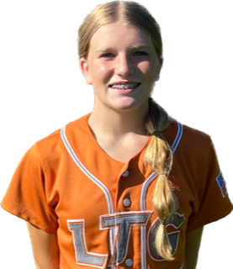 | Ryann Wolfe #25
 | Position:  Birth Mo/Year:  High School: |  |  | C / 2nd / SS  June 2009  Elk Grove High School, Elk Grove, CA
 | ATHLETIC INFORMATION
 | Bats: Right |  | Throws: Right |  | Pop Time to 2B: 1.7 |  |  | Home to 1B: #.##
 | ACADEMIC INFORMATION |  |  |  |  | NCAA Clearinghouse #: ##########
 | GPA Weighted: 4.0 / Unweighted: 4.0 |  |  |  |  |  | SAT: #### |  | ACT: ##
2027 | LTG Lions 14U Henderson/Buck
CONTACT INFORMATION  P. (916) 805-9047  E. Ryann.wolfe.2027@gmail.com  HEAD COACH / LIAISON  Joe Henderson  P. (916) 947-7331  E. joehenderson@frontiernet.net  Amanda Buck  P. (916) 479-5048  E. ltgbuck@gmail.com  SPECIALTY COACHES  Catching:  Lindsey Munoz  Gap-2-Gap Softball  C. (916) 801-8903  Hitting:  Thomas Neal  C. (480)376-6765  Speed, Agility & Conditioning:  Lance Nunez  C. (916) 502-4037 |  | Athletic Accomplishments  - 2023 USA Softball High Performance - selected for tryout in Florida  - 2023 PGF Nationals 14u Premier T-17th Place Finish  - 2023 PGF Organizational Challenge Winners  - 2022 PGF Nationals 12u Premier T-7th Place Finish  ACADEMIC ACCOMPLISHMENTS  - 2021-23 Principal’s Honor Award, KERR Middle School, Elk Grove  - 2021-23 Renaissance Gold Recognition Award, KERR Middle School, Elk Grove  Community Service  - 2023 – Beef and Reef dinner for the Rotary Club -Volunteer/server  travel ball history  - 2023-Current: LTG Lions 14U Buck, Elk Grove  - 2022-23 – LTG Lions 14U Buck, Elk Grove  - 2021-22 – LTG Lions 12U Buck, Elk Grove  - 2020-21 – LTG Lions 12U Buck, Elk Grove  - 2019-20 – LTG Lions 10U Buck, Elk Grove  - 2018-19 - LTG Lions 10U Buck, Elk Grove

